Turbojet Engine Cycle Analysis

Recall, from the discussion of isentropic flow with work that the compressor power is given by, where subscripts 1 and 2 represent the compressor entry and exit stations. For an ideal compressor the temperature and pressure ratios are related by the isentropic expression:

, where pc is the compression ratio.

The turbine power is given by , and for the ideal turbine, the temperature and pressure ratios are related by the isentropic expression:

.

Consider the burner in the gas turbine engine. Fuel, with heating value QR, is added at the rate of . The rate of energy release due to combustion of this fuel with air is , where is the burner (or combustion) efficiency. The mass flow rate through the burner is , and the heat added per unit mass is . As mentioned earlier, *f* is typically small (around 0.02 or 0.03, so it can be ignored in comparison to 1; that is . Therefore, .

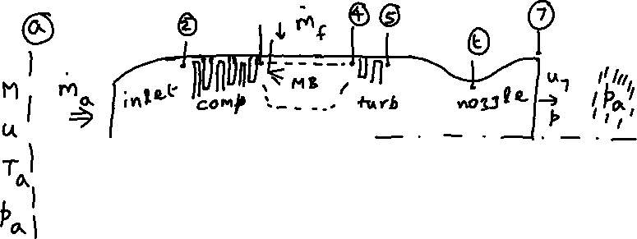

Example:

An ideal turbojet has the following characteristics: M = 2, Ta = 217 K, pa = 19.4 kPa, pc = 22, T04 = 1600 K, fully expanded exhaust jet, QR = 43500 kJ/kg.

1. Perform cycle analysis and find the engine exit stagnation temperature and stagnation pressure. The values of g across the various components are noted in the Figure.
2. Find the specific thrust and TSFC of the engine, and the exhaust nozzle area ratio.

Solution:

Station (a): M = 2, u = M = 590.6 m/s

= 390.6 K

= 151.8 kPa

1. 🡪 (2), inlet diffuser:

= 390.6 K

= 151.8 kPa

(2) 🡪 (3), compressor:

pc = 22, or = 22 🡪  = 3340 kPa

= 2.2665 🡪 = 885.3 K

= - 5.363(105) {negative value indicates work done on air passing through the compressor}

{ = 1084 J/kg-K}

(3) 🡪 (4), main burner:

I law: 🡪 , or

= 0.0205

{ = 1157 J/kg-K}

= 3340 kPa {From Rayleigh line analysis (AE 308), recall that heat addition at zero Mach number entails no loss in stagnation pressure}

(4) 🡪 (5), turbine:

Turbine generates power to drive compressor. This observation constitutes the turbine-compressor power compatibility condition.

= 5.363(105), or

= 5.363(105)🡪 T05 = 1137 K

= 0.2524 🡪 p05 = (0.2524)(3340) = 843 kPa

(5) 🡪 (7), nozzle:

= 1137 K

= 843 kPa

______________end cycle analysis_______________

Fully expanded exhaust jet: p7 = pa = 19.4 kPa

= 4.3454

= 4.3454 🡪 M7 = 3.079 {g = 1.35}

= 427.6 K

u7 = M7 = 1253 m/s

= 662.4

Specific thrust  = 662.4 N/(kg/s)

= (0.0205/662.4) = 3.095(10-5) (kg/s)/N

= 3.095(10-5)(9.81) = 13.036(10-4) s-1 1.093 h-1

Nozzle area ratio is (A7/At) = (A7/A7*) = = 5.039

{g = 1.35}

If the propellant (air) mass flow rate is 100 kg/s,

= (662.4)(100) = 66240 N

= (0.0205)(100) = 2.05 kg/s 7380 kg/h

= 100 kg/s, = 0.1581 kg/m3, u7 = 1253 m/s

= 0.5048 m2 { = 0.80 m 31.5 in.}

= 0.1002 m2 { = 0.36 m 14.2 in.}